

|  |
| --- |
| Riko Wolhuter ST101144082023/03/20 DANA8411  Part 1 |
|  |

|  |
| --- |
| Contents  1. Table of contents………………………………………………………………………………………………………..2 2. Section 1 – Background and Introduction……………………………………………………………………………3 3. Section 1 – Introduction, Descriptive analysis and Organizational problem…………………………..…………4 4. Section 1 - Organizational problem…………………………………………………………………………………..5 5. Section 1 – Data collection, Data cleaning and Analysis…………………………………………………………..6 6. Section 1 – Analysis……………………………………………………………………………………………………7 7. Section 1 – Analysis………………………………………………………………………………………………..…..8 8. Section 1 – Analysis………………………………………………………………………………………..…………..9 9. Section 1 – Analysis and Outcome…………………………………………………………………………………..10 10. Section 1 – Outcome, methods and References………..…………………………………………...………...11-12 11. Section 2 – Background………………………………………………………………………………………………13 12. Section 2 – Introduction…………………………..…………………………………………………………………..14 13. Section 2 – Diagnostic analysis and Organizational problem…………………………………………………….15 14. Section 2 – Organizational problem, Data collection and Data cleaning………………………………………..16 15. Section 2 – Analysis and Outcome…………………………………………………………………………...……..17 16. Section 2 – Methods and References...………………………………………..……………………………….18-19 17. Section 3 – Background and Introduction...……………………………………………………………..………….20 18. Section 3 – Predictive analysis and organizational problem………………………………………………………21 19. Section 3 –Data collection and data cleaning...……………………………………………………...……………..22 20. Section 3 –Analysis…………………………………………………………………………………………………….23 21. Section 3 – Outcome…………………………..………………………………………………………………………24 22. Section 3 - Methods, References…………………………………………………………………………………25-26 23. Section 4 – Background and Introduction……………………………………………………………………….….27 24. Section 4 – Prescriptive analysis and organizational problem……………………………………………………28 25. Section 4 – Data collection……………...………………………………………………………………………..…..29 26. Section 4 – Analysis and data cleaning…………………………………….…………………………..…...…..30-31 27. Section 4 –Outcome and method…………………………………………………...………………………………..32 28. Section 4 –References……………………………………………….…………...……………………………....33-34 |
|  |

# **Hacker Women in Tech – Case study by HackerRank**

## Background



HackerRank is a technology company formerly known as “InterviewStreet”, founded by two qualified Computer scientists Vivek and Hari, established in July 2009. HackerRank’s main product is - an online hiring platform that allows technology companies to hire, screen, and interview software developers. HackerRank’s business model is - assessing developer skills through a recruiting process that HackerRank developed, HackerRank charges the technology companies to use their services to hire the best possible candidates. [3]

When HackerRank started out in 2009, they found that through the traditional interview process, unqualified people were slipping through, making it to the onsite interview, bypassing the Resume review and screening process. The traditional interview process also missed capable individuals due to the fact that they didn’t have a degree or high GPA score. They looked to transform the industry by transitioning from a traditional resume-based hiring process to a skills-based hiring process, to get the skilled individuals employed at the right companies. [3]

In 2018, HackerRank conducted an investigation on women in the tech industry to find out why there is a gender gap of professionals in the field. Through analysis techniques that they performed, they abstracted useful insights, they found solutions to increase female participation in the tech industry. An increase in women involvement and interest in the Technology field could increase participation in HackerRank’s products and services thus increasing revenue. [3]

## Introduction

The analysis the analysts in the case study performed, answered questions: “Why did an occurrence happen?”, “What is happening / happened?”, “What needs to be done?”. [5]

Why use analysis? You use data analysis to clean, change and process raw data/information to extract relevant information that can be taken action on, this process helps businesses make more informed business decisions. [5]

How could I go about analysing data/information? Well you could analyse data/information through the means of Statistics and math by setting hypotheses, parametric models and then compare them to standard metrics of the models, or you could analyse data/information through Artificial intelligence and machine learning that builds the models using the data. [5] [6]

There are four types of Data analysis: Diagnostic analysis that focuses on why an occurrence happened by looking at patterns in the data from the future and the present, Predictive analysis that focuses on what is likely to happen in the future by looking at patterns in the data to predict future events, Prescriptive analysis you look at what needs to be done for a certain problem using the insights you have gathered, and lastly Descriptive analysis you focus on what happened at a certain occurrence in time. [5]

For the purpose of the report, the report will dive deeper into the question of “What is happening / happened?”. So, the report will delph deeper into the descriptive analysis of the Case study. The business wants to gather valuable insight to the answers that they want answering on such as: “What is the gender gap in the tech industry in the past and present?”, “What were the different roles and responsibilities of each gender in the past in the tech industry and how does it compare to the present roles and responsibilities” … and more questions that need answering.

Surveys were conducted, through services like – SurveyMonkey, enabled data analysts to collect a lot of raw data. Approximately 25,090 professionals and student software developers completed the 10-minute online survey. The relevant labels were included in the range of features of the datasets such as: skills, educational background, current role, gender and more. The irrelevant labels weren’t analysed or were either dropped from the datasets such as: Date of birth, home address…etc. [4]

The study was conducted in order to give insight and provide transparency about the people involved in the tech industry and the world as a whole, mainly focusing on understanding trends about women pursuing careers as software developers. [4]

## Descriptive Analysis

**Descriptive analytics – is the process of using current and historical data to gather insights by identifying trends, patterns and relationships. This type of analysis is known as the easiest form of analysis due to the fact that although you look at the trends, patterns and relationships, you don’t dig deeper into the understanding of why the trends, patterns and relationships are taking place.** [1]

**Descriptive analysis is useful for showing trends that change over time, and then using that information to make future analysis, possibly with another data analysis technique such as Prescriptive analysis. Examples of Descriptive analysis being used can be seen with services like Google analytics or YouTube analytic tools that show trends and occurrences with past data in a visual format that is insightful.** [1]

**By looking at the trends and patterns of the analytics, individuals and organizations can acknowledge what worked and what didn’t work at different time intervals for a certain product or service, taking this information into consideration, decisions can be made on where money should be spent, saving money for the stakeholders in the long run.** [1]

**The patterns analyzed will help target customers better, an individual or organization will push, pull and improve on certain products and services during each season because of the insights that were gathered, customers will then only be satisfied and provided for according to the business decisions made.** [1]

KPIs(Key Performance indicators) are used often in business for all of the employees and sometimes for employers. The indicators are compiled using the information gathered from descriptive analysis, the actions made from past work done decides the KPIs – what you must do, must not do and the measures that need to be taken to insure the most optimal working environment and most efficient working version of an individual. [1]

## Organizational problem

### Functional Requirements [7] [8] [9]

* Organizations should be able to sign-up and login to HackerRanks services and products.
* Software developers should be able to sign-up and login to HackerRank’s services and products.
* Organizations should be able to hire and interview software developers through HackerRank’s website.
* Software developers should be able to view and apply for job openings shown on the HackerRank’s website by Organizations.
* Software developers should be able to take coding tests and coding interviews on the HackerRank’s website.
* Organizations should be able to pay for services through HackerRanks payment plan.
* Through associated Universities and Organizations they should be able to recruit software developers through HackerRank’s website.
* There needs to be diversity and inclusion for all participants using the services and products.

### Non-Functional Requirements [7] [8] [9]

* Organizations and developers should be able to sign-up and login to HackerRank’s services and products timelessly, within seconds, with little to no effort.
* HackerRank is reliable and secure, it uses modern technology and security measures to insure the integrity of users information. Uses Amazons Web Services infrastructure, for optimal performance.
* Quick response to an increase in user load, using the website with its services and products.
* Amazon’s Web Services infrastructure delivers 99.9% uptime.
* Amazon Web Services (AWS), a secure cloud services platform, complies with all major security standards including ISO 27001, SOC 1/SOC 2/SSAE 16/ISAE 3402.
* End-to-end encryption of all customer data using 128-bit SSL encryption.
* Authentication once signed in, it has single sign-on (SSO) capabilities via SSO partners or the preferred SAML 2.0-compliant solution.
* APIs automate repetitive tasks such as test administration and fetching results.
* HackerRank complies with global privacy standards, ISO 27001, EU’s General Data Protection Regulation (GDPR).

HackerRanks mission is to “accelerate the worlds innovation”. The Stakeholders are – co-founders Vivek Ravisankar and Harishankaran K. Investors of HackerRank are: JMI Equity, randstad, file:recruit, Battery ventures, khosla ventures and SVAngel. The stakeholders and investors are looking to upkeep the 200+ employees that they have working at their company, provide to the 3000+ customers using their products and services, and help the 21+ million software developers with their careers. The stakeholders and investors are obsessed with making their customers happy and helping others achieve their goals. [3] [7]

With positive customer stories showcased on HackerRank’s main website and the fact that HackerRank as a brand and a company is associated with many notable other brands and organisations, customers feel positive and happy using HackerRanks products and services. [3] [7]

HackerRank conducted a case study in 2018, where they surveyed 25,090 software developers - students and professionals alike. The case study only used a sample of 14000 software developers to conduct their analysis, out of the 14000 of software developers, of those that were women are 2000 women, this is where the big organisational problem lies, HackerRank’s data analysts has to investigate and analyse the data to give insight on what the data says for the gender gap in the tech industry. [2] [4]

HackerRanks current products and services are inclusive as they allow anyone to sign up and use HackerRank to hire software developers and get hired as a software developer. HackerRank could maybe emphasise through marketing and those involved in the HackerRank ecosystem that female software developers are welcome and maybe offer better deals compared to their male counter parts to shift away from the assumption that Males are better at coding than what females are. Females need to be part of the leadership team and need to be put into plans for eventual higher up senior positions. Females in the tech industry need to speak their truth and need to be valued. [2] [3] [7]

Once the analysis is done, HackerRank wants to gain a competitive edge over their rivals, being leaders in their field, by having greater customer retention(Organisations and software developers included) over their competitors, obtaining an eventual even male to female ratio employed at HackerRank and associated organisations before their competitors and lastly to be known as the technology hiring company that values females and their software developer skills that they provide and contribute to their work.

HackerRank can create exclusive courses, seminars, employment opportunities…etc. as part of HackerRank’s products and services package for female software developers, run by female software developers for female software developers.

# Data analytics approaches/methods

## Data Collection

## The survey that was used to collect data was hosted through a service called SurveyMonkey, a first-party source of data collection, HackerRank directly collected its data from the research participants. From the 25090 surveys received the Women in Tech 2018 report only uses 14000 survey responses. The survey questions that were asked was relevant to the case study conducted and the analysis that had to take place such as: Gender, skills, educational background, current role, and more. Not every question was shown to every respondent, different questions were asked for Hiring agents and other questions were asked for software developers. Of the 14000 survey responses only 2000 were female, this is the part of the dataset that we will analyse. [2] [4]

There were five datasets that were analysed and merged into a single dataset: 1.Country-Code-Mapping.csv that collected the mapping of the numeric country code associated with the corresponding country, 2.HackerRank-Developer-Survey-2018-Codebook.csv that collected questions corresponding to the column names, extra notes and what the correct answers were to coding questions, 3. HackerRank-Developer-Survey-2018-Numeric-Mapping.csv that collected the mapping from the numeric values, and what their textual representation in the survey was, 4. HackerRank-Developer-Survey-2018-Numeric.csv the raw survey responses, 5. HackerRank-Developer-Survey-2018-Values.csv the text version of the survey responses. [4]

## Data Cleaning

The survey responses that were incomplete or detected as spam was removed from the dataset. The dataset was grouped by gender, one group that was female and another that was male, the survey respondents that identified as “non-binary” were excluded from the data, so that male-female comparisons could be made. [4]

## Analysis

When analysing the data, we want to focus on the gender counter parts and answer some of these questions: What languages are they learning, how they learn, what’s their career growth like, and more. [4]

Questions that needed answering that were not gender related were: How are responses from students different from professionals? Is there anything we can learn from their different priorities or preferences? Is there interesting deeper analysis of the 'other' roles that were input beyond the ones we categorized in the survey? What trends we can see by looking at the different cohorts (beyond what we already outlined)? Is there more to discover in trends of educational backgrounds, languages/frameworks known that we have not explored? Are there important findings that are actionable in the community at large to continue to support women? What are the largest issues you see facing women in Computer science? Where should the tech industry go from here? What types of initiatives have been working? Testing was done at the .01 level (99% probability that the model is real). [4]

### Focus of the analysis

We can make the assumption that: women in the tech industry is a minority. Women in the tech industry need to be empowered and the wage gap between females and males needs to be addressed. The women in this analysis have been prioritised to find out more about what the past data is telling us, the analysis could help future initiatives. [4]

### Findings

It used to be that female software developers came from majors outside of computer science and STEM (Science, Technology, Engineering or Math). And men most likely came from computer science degrees. Women today are 33% more likely to study computer science when compared to the women before 1983. (Figure 1) [2] In 1980 kids were curious to learn how to code at a young age but over time as technology has been embedded in society, the desire to learn to code before the age of 16 has been declining. (Figure 2) [2]

### 

(Figure 1) [2] (Figure 2) [2]

Women say they have proficiency in these languages: Java, JavaScript, C, C++, and Python. These are also the most in-demand languages in industry currently for roles in front-end, back-end, and full-stack. (Figure 3) [2]

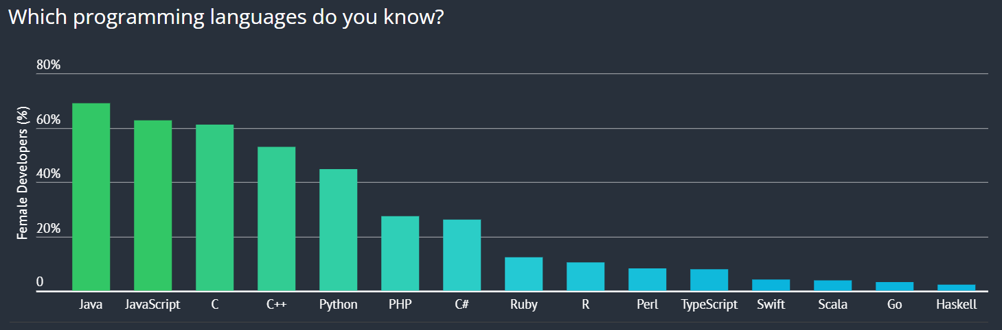

(Figure 3) [2]

Women that program, are building software for different industries, the most popular are - technology (53.3%), finance (10.7%), and education (5%). (Figure 4) [2]

Women are more likely to be in junior software developer roles than men are regardless of age. (Figure 5) [2]

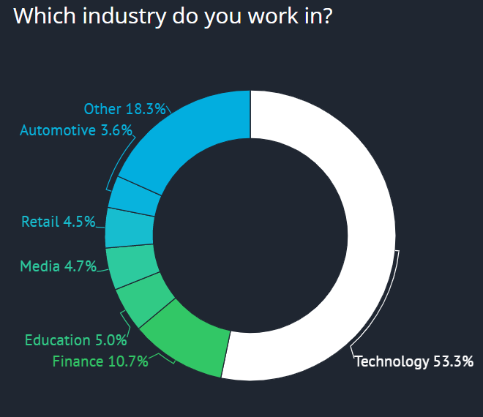 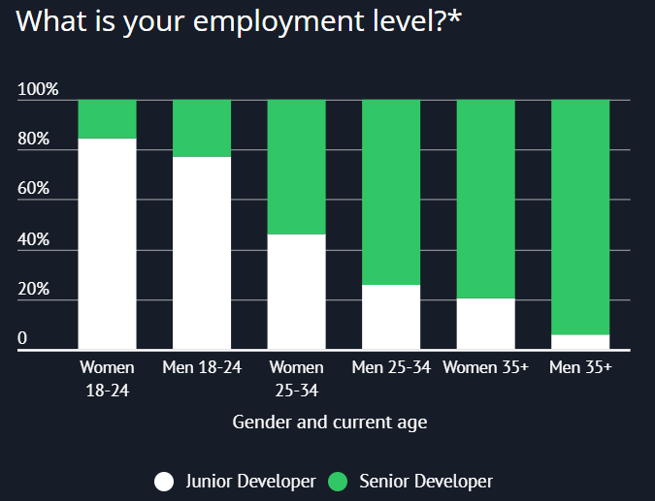

(Figure 4)[2] (Figure 5) [2]

### Women that are over the age of 35 are 3.5% more likely to be in junior roles than men. (Figure 6) [2]

The ratio of female to male working as software developers is 16.5% to 83.4%. (Figure 7) [2]

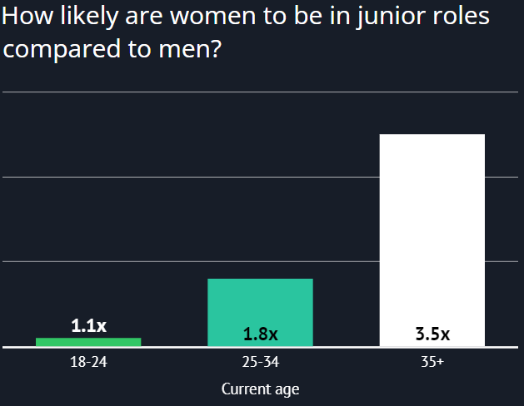 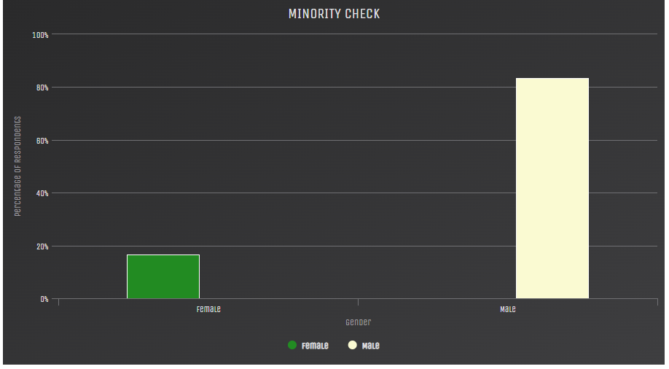

(Figure 6)[2] (Figure 7) [2]

In the age bracket 5-10yrs of starting coding, men are 4 times more likely than women. In the age bracket 11-15yrs of starting coding, 22% of men started at this age whereas 13% of women started at this age. (Figure 8 and 9)

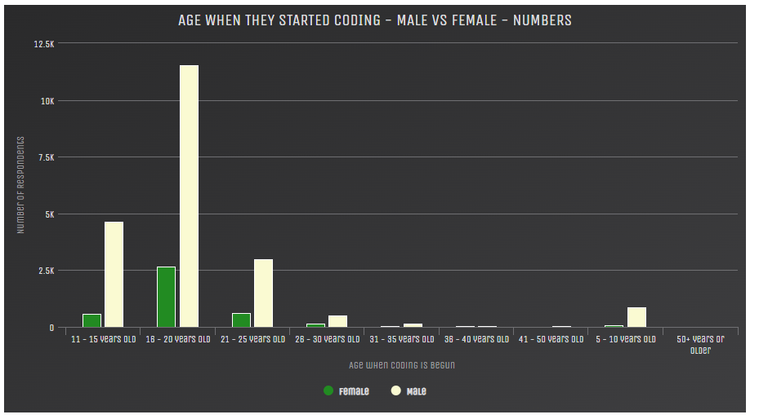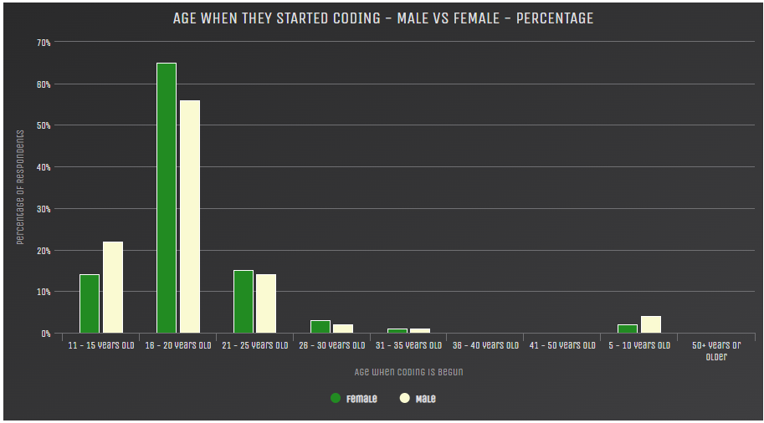

(Figure 8)[2] (Figure 9) [2]

Computer Science as a major only 16% of students are female while the rest are male. (Figure 10, 11 and 12)

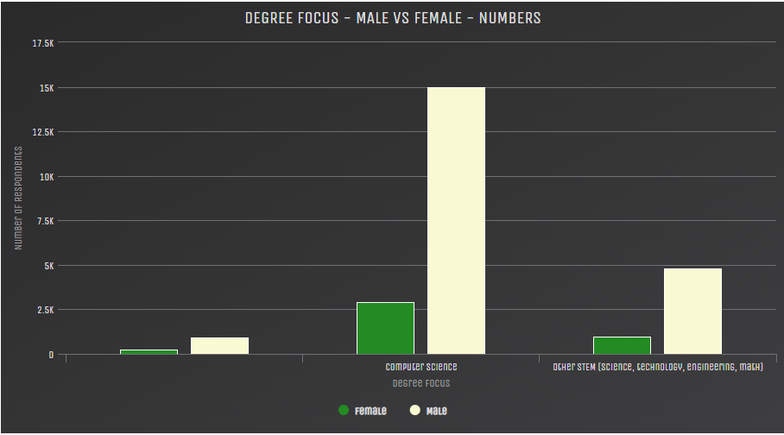 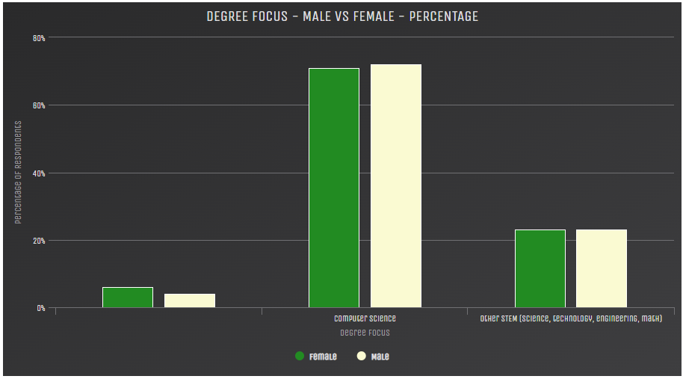

### (Figure 10) [2] (Figure 11) [2]

### 

(Figure 12) [2]

In the countries of Sudan, Republic of Moldova and Palestine, females are most involved in tech and coding, maybe to make better lives for themselves as they come from developing countries. (Figure 13, 14 and 15)

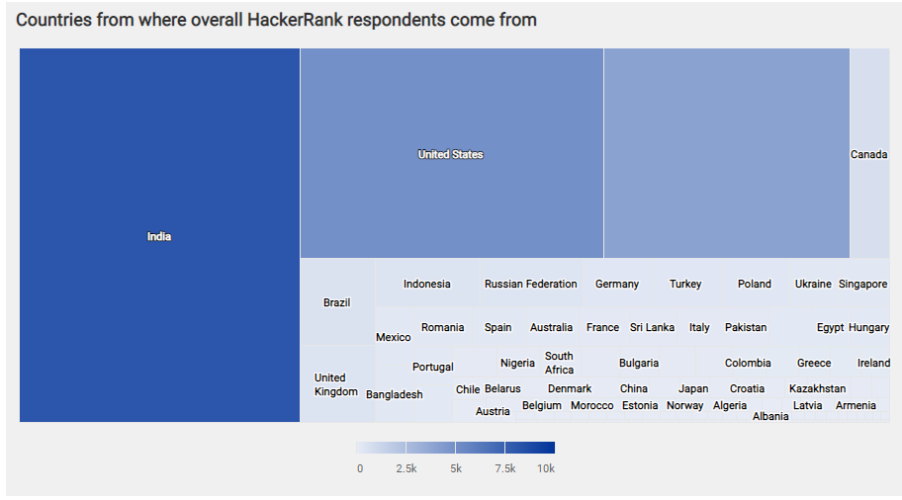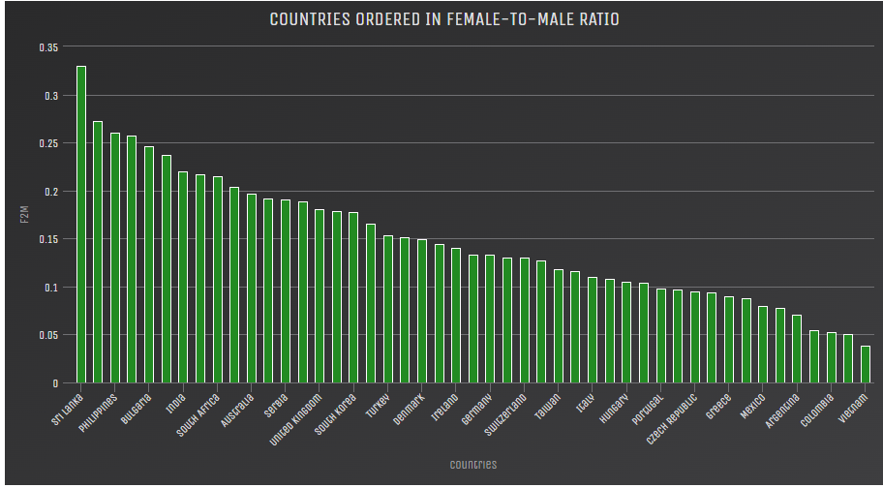

(Figure 13)[2] (Figure 14) [2]

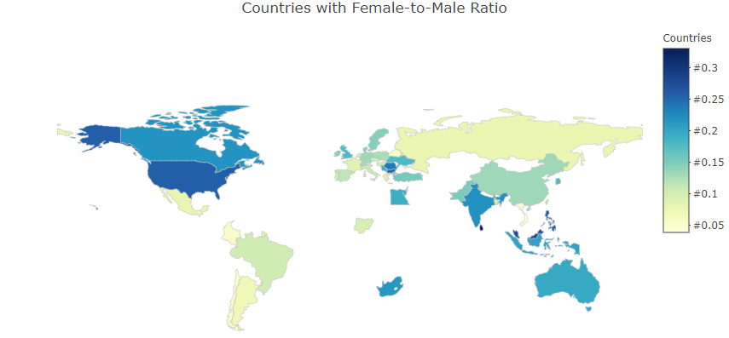

(Figure 15) [2]

Developers on the HackerRank website, majority of females are at the starting point of their careers whereas males are mostly senior developers. (Figure 16 and 17)

### 

(Figure 16) [2] (Figure 17) [2]

What do females want in a tech job? Remote work and work environment? (Figure 18 and 19)

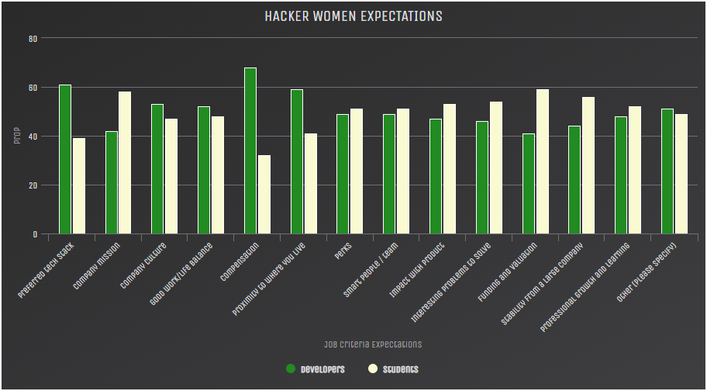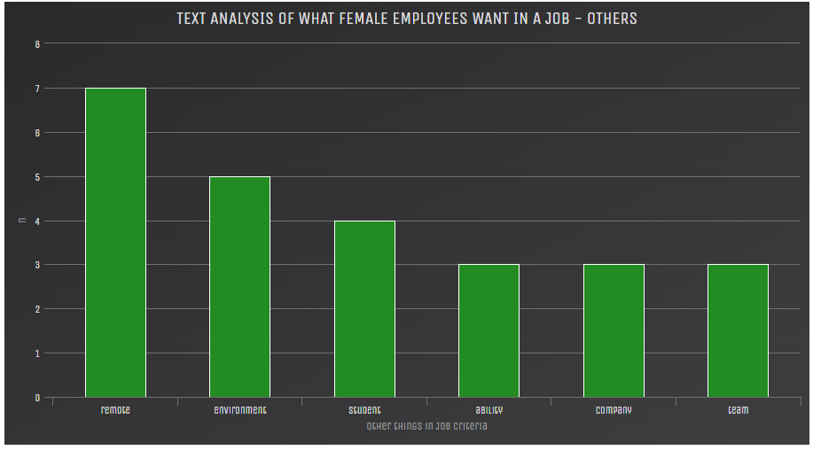

(Figure 18) [2] (Figure 19) [2]

Only 10,3% of hiring managers are female, thus females have less authority to hire.(Figure 20)

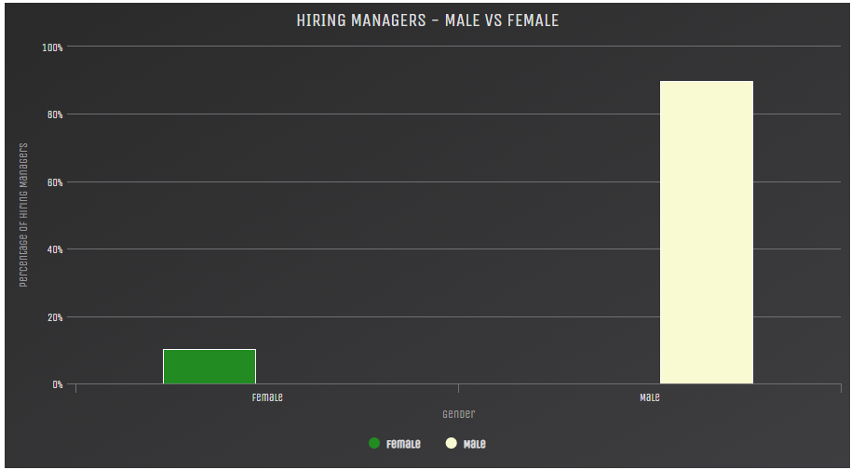

(Figure 20) [2]

## Outcome

There are more women students participating in HackerRank than ever before, industry has been looking to be more inclusive with the people that they are involved with. Developer forums have been striving for a better future thus shaping the future of the technology industry and the female’s involvement therein. The industry has been trying to motivate and appreciate girls learning to code at the present time and to be more inclusive with the females at high schools. More parents have been educated about the importance of coding as a skill and that their daughters need to get involved. As per the perception, people think that Computer Science as a degree is a major that boys do well in but the truth is females can be just as good and it has been made

prevalent as of late. Proportion of female Computer science students have been improving compared to the past. Females need the same amount of attention or even more attention to preserve them, hone them and take them forward to prevent them from dropping off. In the developing nations – Africa nations are leading in the female-to-male ratio. There is a importance to move women up from their junior roles to senior roles as developers, Sabbaticals pushed for women who want long leaves with a surety that there will be a job for them when they get back. There is a clear learning path for new aspiring software developers, they will be put on a track to learn the most in-demand programming languages. [2] [4]

## Why data analytic’s approaches/methods were used

The descriptive analysis techniques were used in this case study to summarize and describe the characteristics of the dataset/s being used. The techniques help to identify the patterns, trends, and relationships in the data. We can draw comprehensive information from the data, including measures of central tendency, measures of dispersion and visualizations.

The descriptive analysis techniques helped us to answer research questions that we wanted answering to, such as one of the research questions “What languages are they learning, how they learn, what’s their career growth like?”, the analysis could help us to identify the most commonly learned programming languages, the most popular learning methods, and the career growth trajectory of software developers in the IT field.

# Bibliography

Descriptive analysis:

[1] online.hbs.edu. 2023. WHAT IS DESCRIPTIVE ANALYTICS? 5 EXAMPLES. [ONLINE] Available at: <https://online.hbs.edu/blog/post/descriptive-analytics#:~:text=Descriptive%20analytics%20is%20the%20process,but%20doesn't%20dig%20deeper.>. [Accessed 23 March 2023].

[2] hackerrank. 2023. 2018 Women in Tech Report. [ONLINE] Available at: <https://www.hackerrank.com/research/women-in-tech/2018>. [Accessed 23 March 2023].

[3] hackerrank. 2023. About Us. [ONLINE] Available at: <https://www.hackerrank.com/about-us/>. [Accessed 23 March 2023].

[4] Kaggle_Member, A., 2018. Hacker Women in Tech - HackerRank Analysis. *HackerRank Developer Survey 2018*, [Online]. 88, 1. Available at: <https://www.kaggle.com/code/nulldata/hacker-women-in-tech-hackerrank-analysis/report> [Accessed 14 March 2023].

[5] simplilearn. 2023. What is Data Analysis? Methods, Process and Types Explained. [ONLINE] Available at: <https://www.simplilearn.com/data-analysis-methods-process-types-article#:~:text=Data%20analysis%20helps%20businesses%20acquire,the%20company's%20vision%20or%20mission.>. [Accessed 12 April 2023].

[6] jpt.spe.org. 2023. Traditional Statistics vs. Artificial Intelligence and Machine Learning. [ONLINE] Available at: <https://jpt.spe.org/traditional-statistics-vs-artificial-intelligence-and-machine-learning#:~:text=While%20traditional%20statistics%20tests%20hypotheses,it%20fits%20the%20predetermined%20models.>. [Accessed 12 April 2023].

[7] hackerrank. 2023. Trust at HackerRank. [ONLINE] Available at: <https://www.hackerrank.com/trust/>. [Accessed 12 April 2023].

[8] westerncape.gov.za. 2023. An introduction to the Protection of Personal Information Act (or POPI Act or POPIA). [ONLINE] Available at: <https://www.westerncape.gov.za/site-page/introduction-protection-personal-information-act-or-popi-act-or-popia#:~:text=The%20POPI%20Act%20sets%20out,sharing%20of%20any%20such%20information.>. [Accessed 12 April 2023].

[9] unctad.org. 2023. Data Protection and Privacy Legislation Worldwide. [ONLINE] Available at: <https://unctad.org/page/data-protection-and-privacy-legislation-worldwide>. [Accessed 12 April 2023].

[10] machinelearningmastery. 2023. Overfitting and Underfitting With Machine Learning Algorithms. [ONLINE] Available at: <https://machinelearningmastery.com/overfitting-and-underfitting-with-machine-learning-algorithms/#:~:text=Overfitting%20refers%20to%20a%20model,the%20model%20on%20new%20data.>. [Accessed 12 April 2023].

[11] investopedia. 2023. Quantitative Analysis (QA): What It Is, How It's Used in Finance. [ONLINE] Available at: <https://www.investopedia.com/terms/q/quantitativeanalysis.asp>. [Accessed 12 April 2023].

[12] towardsdatascience. 2023. Understanding the Bias-Variance Tradeoff. [ONLINE] Available at: <https://towardsdatascience.com/understanding-the-bias-variance-tradeoff-165e6942b229>. [Accessed 12 April 2023].

# Evaluation of development of Apple Inc. stock price time series – case study done on Apple Inc.

## Background



Apple Inc. is an American technology company, formerly known as Apple Computer Inc., focused in manufacturing personal computers, smartphones, tablet computers, computer peripherals, and computer software. The company was founded in 1976 by co-founders Steve Wozniak and Steve Jobs. Apple’s products today include: Apples operating system software, the iPhone, the Mac, the iPad, AirPods, the Apple TV, the Apple Watch, Beats products, HomePod, the iPod touch and accessories. Apple’s business model is focused primarily on selling its products and services, services including Apple TV+, Apple Fitness+, Apple Music, iCloud+, and Apple Arcade. [17] [19]

Apple Inc. had many successes due to the innovation of their products and services, the innovations made, solved many problems faced. [17]

In the 90s apple developed many successful products: the Apple 2 computer that many computer programmers used as their choice of computer, a disk controller that acted as a low-cost floppy disk to store information reliably and quickly, useful primary-school software was also developed. [17]

Apple developed the first functional graphical user interface (GUI) for its products, with the GUI a pointing device known today as the mouse, the GUI featured – icons and pictures, one of the first of its kind at that time. In 1985, Apple developed an affordable laser printer along with Aldus Corporation’s PageMaker, at this point Apples revenue approached $10 billion. [17]

Apple Inc. created its own operating system for its products known as Mac OS. At this point in time, Apples financial situation was dire, Apples market share fell to 3 percent, the board of directors in Apple brought back one of the co-founders Steve jobs to get the company back on track, Steve Jobs was first the advisor then became the CEO and immediately after that the primary leader of the company. [17]

With the release of the iMac, Apples market share increased from 2.6 percent to 13.5 percent from December 1997 to August 1998. In 2001, Apple released iTunes, software that allows you to play music and convert music into mp3 format. Apple released the iPod, a portable MP3 player. In 2007, the Apple iPhone was released, a touch-screen phone. [17]

In 2011, Steve Jobs resigned as CEO at Apple Inc., the position was taken over by Tim Cook. In 2018, Apple Inc. became the first company to reach a valuation of one trillion dollars, two years later the company reached a valuation of two trillion dollars. [17]

## Introduction

Apple Inc. and its employees push the envelope every day and seek to gain any competitive advantage over its competitors. “Why do an analysis on Apple’s stock prices over time?”, the analysis done in the case study seeks to find out what made Apple Inc. so successful, looking at all the high and low points of its stock price during the lifespan of the company. [18]

Why use analysis? You use data analysis to clean, change and process raw data/information to extract relevant information that can be taken action on, this process helps businesses make more informed business decisions. [5]

There are four types of Data analysis: Diagnostic analysis that focuses on why an occurrence happened by looking at patterns in the data from the future and the present, Predictive analysis that focuses on what is likely to happen in the future by looking at patterns in the data to predict future events, Prescriptive analysis you look at what needs to be done for a certain problem using the insights you have gathered, and lastly Descriptive analysis you focus on what happened at a certain occurrence in time. [5]

For the purpose of this report, Diagnostic analysis will be used to answer the main question “Why did an occurrence happen?”

The most common contributing factors to an increase and decrease in the stock price of the company was: the products, services, customer satisfaction or dissatisfaction, demand over supply, economic and political situations, the analysis will delph deeper into those occurrences. One of the questions wanting answers to was – “Why while other technology companies struggled during economic crises and Covid-19, Apple Inc. was not heavily affected by the crises and neither were Apple’s stock prices?”. The factors were evaluated using several statistical methods, the most conclusive method that was used is the so-called time series, it assesses the stock price development and its performance in the past. The analysis used secondary party source data in the years of 2000 – 2020. The time series tracked highlighted: certain occasions and the results of certain circumstances on the financial market. [18]

Notable time horizons –

1. In the years 2000- 2020 what factors affected the share prices?
2. How were the stock prices affected during the COVID-19 pandemic in the year 2020?
3. What was the development of the stock prices during the 2007-2009 economic crisis?

[18]

The data collected was analyzed both qualitatively and quantitatively. [18]

Visualizations were generated and illustrated according to the resulting values, showing the fluctuations of the stock price and the causes of the fluctuations. Events were correlated to excessive fluctuations and analyzed further for what affected the fluctuations. Separate visualizations and tables were generated for the time period of the COVID-19 pandemic, when the worlds economic situation was at its most shacky. [18]

## Diagnostic analysis

Diagnostic analytics - is an advanced form of analytics where you analyse data and you want to answer the question of “Why did it happen?”. The techniques used for this analysis are: drill-down, data discovery, data mining and making correlations. [13] [21]

Diagnostic analysis takes what is learnt from descriptive analytics and finds the causes of the outcomes. When performing Diagnostic analysis you might use different techniques such as probability theory, regression analysis, filtering, and time-series analysis. The case study in our instance is using time-series analysis. [13] [21]

Time-series analysis looks at different data points over certain intervals in time. The data points in the analysis are not selected at random but consistently over a set period of time. [13] [21]

Diagnostic analysis can either be done manually through mathematical statistics and the use of algorithms or by using statistical software such as using Microsoft Excel. [13] [21]

Diagnostic analysis is just one of the steps in analysing data, once the data is collected, analysed and correlations are found about why certain occurrences happened, then the organization can make informed business decisions. Once the groundwork is done, it lays the foundation to make further analysis on data, to predict future outcomes and form a plan of action. [13] [21]

Diagnostic analysis’s findings highlight all the decisions made in the company, the mistakes made that resulted in negative outcomes for the company and the correct decisions made that resulted in growth and positivity in the company. From the findings, actionable decisions can be made from the findings, saving an organisation money in the process. [13] [21]

One of the factors that fluctuate the stock market of Apple Inc. is the customer satisfaction or dissatisfaction of certain products or services, looking at the fluctuations and the occurrences that happened at that point of time can help steer business decisions being made, to keep what made the customers satisfied and remove or improve on what made the customers dissatisfied. [14] [18]

## Competitive advantage the organisation hopes to gain

In 1997, when Steve jobs came back to take control back of the company, he transformed the business from a conventional structure into business units, each business unit having its own responsibilities, the different departments were put into a single functional organization that aligns with the decision rights and expertise that Steve Jobs formulated. [17] [22]

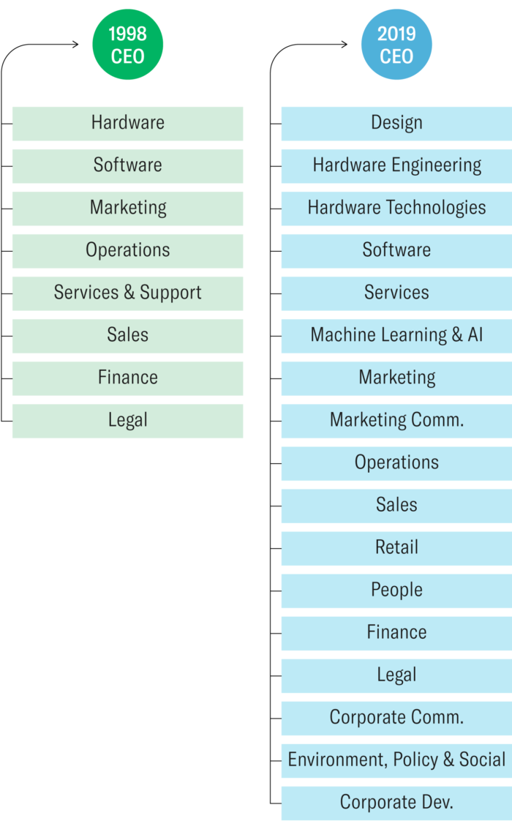 (figure 21)

According to organizational theory and business history – as entrepreneurial firms grow large and complex, there needs to be a shift from a functional structure to a multidivisional structure, this will align accountability and control throughout the organization. [18] [22]

With the advancement of artificial intelligence and other areas, the business structures of big organisations are changing.

Apple’s main purpose is to create products that enrich the lives of their customers. Not only are they creating new innovative product categories such as creating smart devices, but they are continually innovating in those categories. But with innovation comes expertise and Apple needs a lot of expertise, people with enough knowledge and skills to cover the domains and make the correct decisions in those domains at Apple Inc. [22]

Apple competes in a market where the rates of technological advancement and technological distribution is high, there is a reliance on the intuition and decisions made by the people, with the deep knowledge of the technologies. Before predictions can be made on what the market will do and what products will be successful, Apple has to take certain bets on their designs and technologies that are likely to succeed in all the innovative product categories that they have going on. Relying on technical experts will increase the odds of Apple’s bets paying off. Apple Inc. mission would be counter intuitive if it only looked to reap the rewards of short term profits and cost targets, the products are somewhat insulated from short-term financial pressures, the project roadmap that executives have created, forecasts a long term investment where the products are ever changing and improving. Apple sees their costs and revenue goals different to how conventional organised companies do, instead of using cost and price as targets, as their parameters, which determines how their products will be designed and engineered, the benefits to their users are weighed more significantly than the overall cost considered. [22]

The competitive edge Apple is trying to have over its competition is that Apple’s products are cutting-edge and different, but most importantly that their products are the most innovative. Apple looks at the lives of people, they learn what humans need and what humans can’t live without, then they fill that gap by releasing a corresponding product or service. Although Apple’s products have always been technologically advanced, their products were always simplistic, in the sense of easily accessible devices and easy to use. [22]

# Data analytics approaches/methods

## Data collection

Data for the analysis was collected through the finance.yahoo.com website. Daily data was collected for the period of 2000-2020. The data was processed to a Microsoft Excel spreadsheet, so that the data could be used in a csv. Format. The dataset consisted of 5,283 rows. [18]

Secondary party source data was used to collect data, Yahoo is not associated with Apple Inc. but because Yahoo had collected data on Apple, Apple could use Yahoos information to perform the analysis as a secondary source. Yahoo puts out accurate and factual information as they have a reputation and they fact check everything, stock price data on Apple can be found everywhere as Apple Inc. is on the New York stock exchange, trading is done in North America but buying and selling the shares is done worldwide. The time series analysis used, compared comparable data by time, using statistical methods: median, mode, arithmetic mean, variance, variance range and maximum and minimum value. The statistical methods were calculated in Excel for each segment. [18]

Data cleaning

For data cleaning purposes, irrelevant data was excluded and removed from the dataset. Columns showing the dates and the closing prices of the Apple stocks are kept in the dataset. [18]

## Analysis

### Statistical characteristics

For the time series of the stock price of Apple Inc: the mean(average) share price was $9.19, the mode(appeared most frequently) was $0.35 throughout 2000 to 2020, the mean(average) stock price was $18.70, the variance was $565.48 and the standard deviation(difference between maximum and minimum values was $136.45. [18]

### Diagnostic analysis

The stock price reached a all time high in December 2020($136.69) and the lowest stock price was in April 2003($0.23). In Apples early days of starting out (2000-2003), Apple was ramping up production, their expenses were more than their profits and Apple had to take bets to grow the business, so their stock price was low but what made the lowest stock price its lowest was the fact that Apple had to borrow money from Microsoft($150 million) to pay off debt and bills, Apple’s iPod didn’t see much success when it came out further hindering Apple’s stock price on the market. One of Apples real successes was in their service iTunes that turned over real profits and made the stock increase gradually from the year 2004. In the year of 2007 their was a financial crisis but Apple released their first iPhone, causing amount of stocks purchased to increase to $24,000 per share. In 2009 the financial crisis hit the stock markets and Apple Inc. lost 70% of its market value. When Apple Inc. introduced new products in 2010, the iPhone 4 and iPad, the stock price increased to the highest its ever been up until this point of $40,000 per share. Steve Job’s death, the CEO and co-founder of Apple Inc. did not really affect Apple’s stocks that much but it grew steadily from that point. In 2014, Apple introduced wearable products like the Apple iWatch, due to the popularity of the new product, Apple’s stock prices grew more gradually. In 2016, Apple had made a mistake with removing a certain feature of its new product release, by removing the audio jack from its new iPhone 7, stock prices fell. In 2018, Apple released an abundant of new products and services like the new IOS 12 operating system software running on its products, stock prices grew gradually again. In 2019, their was a political issue between China and North America, there was trade war going on between the two countries, this caused Apple’s stock price to drop massively as China was Apples third largest market. In 2020, when the global pandemic hit the world(Covid-19), Apple released its best phone product yet, which caused Apples stock price to increase to an all time high of $136.69 share price. Although other industries and other organizations financial situations became dire due to the pandemic, Apple kept their stock price steady and it even grew, because of peoples change of behaviour - more people were staying inside, people were using more of their devices out of boredom, for work, for news, for entertainment and more. Demand for Apples devices grew, sales increased by 18,6%. [18]

## Outcome

The purpose of the analysis done on the time series of Apple’s stock price was to evaluate the results of circumstances in the financial market. Three specific periods were analysed: during the Covid-19 pandemic(2020), economic crisis(2007-2009) and the years 2000-2020 overall. The conclusion can be made, looking at all the occurrences, that fluctuations in the stock price of Apple Inc. are due to multiple factors that include: new Apple product releases, change in the prices of Apple’s products, customers feelings towards the products and services, events being held by Apple Inc., operation of the company and product accessories.

The results of the findings can be used to perform further analysis, predicting future fluctuations in Apples stock price due to various factors. New courses of actions can be made to solve or improve on Apple’s issues.[18]

## Why data analytic’s approaches/methods were used

The Diagnostic analysis approaches/methods used in the case study was helpful in identifying root causes to a problem or issue. These approaches/methods are commonly used in analyzing stock markets and a company’s performance, by identifying the patterns and trends, this will help in explaining why certain events occurred.

The diagnostic analysis techniques helped us to answer research questions that we wanted answering to, such as one of the research questions “What were the key factors that have influenced Apple's stock prices over time?”, the analysis would be able to help us in identifying these key factors. The analysis would also be helpful in identifying underlying drivers of performance.

Diagnostic analysis helps a business in understanding its strengths and weaknesses and therefor to make more informed investment decisions.

# Bibliography

Diagnostic analysis:

[13] gartner. 2023. Diagnostic Analytics. [ONLINE] Available at: <https://www.gartner.com/en/information-technology/glossary/diagnostic-analytics#:~:text=Diagnostic%20analytics%20is%20a%20form,discovery%2C%20data%20mining%20and%20correlations.>. [Accessed 23 March 2023].

[14] RAHMAN, K., 2023. Apple - Stock Performance - Using Altair. *Apple Stock Data - Live and Latest - From IPO Date*, [Online]. 3, 1. Available at: <https://www.kaggle.com/code/kalilurrahman/apple-stock-performance-using-altair> [Accessed 23 March 2023].

[15] indiatimes. 2023. Product Delays, Spending Cuts: How Apple Has Managed To Avoid Layoffs So Far. [ONLINE] Available at: <https://www.indiatimes.com/technology/news/how-apple-avoids-layoffs-in-this-economy-596543.html>. [Accessed 23 March 2023].

[16] wsj. 2023. How Apple Has So Far Avoided Layoffs: Lean Hiring, No Free Lunches. [ONLINE] Available at: <https://www.wsj.com/articles/how-apple-has-so-far-avoided-layoffs-lean-hiring-no-free-lunches-11674274185>. [Accessed 23 March 2023].

[17] britannica. 2023. peripheral device. [ONLINE] Available at: <https://www.britannica.com/technology/input-output-device>. [Accessed 12 April 2023].

[18] Horák, J. and Kaisler, D., 2022. Evaluation of development of Apple Inc. stock price time series. *SHS Web of Conferences*, [Online]. 1, 9. Available at: <https://www.shs-conferences.org/articles/shsconf/pdf/2022/02/shsconf_ies2021_01012.pdf> [Accessed 12 April 2023].

[19] businessmodelanalyst. 2023. Apple Business Model. [ONLINE] Available at: <https://businessmodelanalyst.com/apple-business-model/>. [Accessed 12 April 2023].

[20] gartner. 2023. Diagnostic Analytics. [ONLINE] Available at: <https://www.gartner.com/en/information-technology/glossary/diagnostic-analytics#:~:text=Diagnostic%20analytics%20is%20a%20form,discovery%2C%20data%20mining%20and%20correlations.>. [Accessed 12 April 2023].

[21] online.hbs.edu. 2023. WHAT IS DIAGNOSTIC ANALYTICS? 4 EXAMPLES. [ONLINE] Available at: <https://online.hbs.edu/blog/post/diagnostic-analytics>. [Accessed 12 April 2023].

[22] hbr. 2020. How Apple Is Organized for Innovation. [ONLINE] Available at: <https://hbr.org/2020/11/how-apple-is-organized-for-innovation>. [Accessed 12 April 2023].

[23] appdore. 2023. 3 Reasons Apple Beats the Competition. [ONLINE] Available at: <https://appdore.com/3-reasons-apple-beats-competition/>. [Accessed 12 April 2023].

# KickPredict: Predicting Kickstarter Success – case study on Kickstarter

## Background



Kickstarter is an American public benefit corporation; the company was launched on the 28th of April 2009. Kickstarter is a place that provides crowdsource funding for personal projects to take place. [27] [29]

The company was co-founded by Perry Chen an American artist, Yancey Strickler an American author and Charles Adler an entrepreneur. One day Perry Chen came up with the wonderful idea – “What if people could go to a site and pledge to buy tickets for a show? And if enough money was pledged, they would be charged and the show would happen. If not, it wouldn't”, from that point on they started to develop their idea. In 2006, Perry and Charles drew up wireframes and specifications for a website that they wanted to create and launch to the public, but none of them could program the website, the project was left until the summer of 2008 where they got a developer to program the website for them. [27] [28] [29]

Once Kickstarter was launched and released to the public, many crowd funding projects started to signup with Kickstarter, many noticeable brands and projects became a success, Kickstarter had become what it was meant to be, to help bring creative projects to life.

Kickstarter’s business model is to take 5% of the money funded on the website.

The dilemma that Kickstarter and crowd funders are left with and still struggle with today is – “Whether a Kickstarter project will be successful and therefore is the project a good backing?”. The report will further investigate into this dilemma.

## Introduction

The case study focuses on predicting the future of Kickstarter projects if they will be successful or not. Through predictive analysis, a machine learning algorithm could be used to build the predictive model, to make future predictions. [26]

Why use analysis? You use data analysis to clean, change and process raw data/information to extract relevant information that can be taken action on, this process helps businesses make more informed business decisions. [5]

There are four types of Data analysis: Diagnostic analysis that focuses on why an occurrence happened by looking at patterns in the data from the future and the present, Predictive analysis that focuses on what is likely to happen in the future by looking at patterns in the data to predict future events, Prescriptive analysis you look at what needs to be done for a certain problem using the insights you have gathered, and lastly Descriptive analysis you focus on what happened at a certain occurrence in time. [5]

For the purpose of this report, Predictive analysis will be used to answer the main question “What is likely to happen in the future?”

## Predictive analysis

Predictive analysis – using historical data to predict future trends, events and potential scenarios. The findings drive business decisions to make the right decisions according to the forecasted results. [31] [32]

Predictions can be made in the near future or the distant future. Predictions are either done manually using mathematical statistics(regression equation) or through machine learning, where you train your predictive model to be used to make predictions. Machine learning algorithms that can be used are: Linear regression, Logistic regression, Decision tree, SVM algorithm, Naive Bayes algorithm, KNN algorithm, K-means, Random forest algorithm. [31] [32]

Data analysis can be done through the techniques of data mining by looking at large sets of data then drawing patterns from the data. Data analysis can be done through the techniques of text analysis but this type of analysis only looks at the large blocks of text. [31] [32]

Predictive analysis is used for analysis on regression data: determining the relationship between variables either between two variables(single linear regression) or three or more(multiple regression). [31] [32]

Predictive analysis is usually done in cohesion with other analysis to make the right business decisions, after answering the questions “What happened and why did it happened”, then predictive analysis is done to answer “What might happen”, the past and future data would then be looked at simultaneously to answer the question “What should be done?” so that strategies can be formulated. [31] [32]

Predictive analysis can improve operational efficiencies and reduce risk, saving an organization a lot of money. Businesses can take advantage of predictive analysis to predict customer behavior, then they can plan their advertising and marketing campaigns to the behavior. Businesses can determine the probability of success of their products before the launch of the products, they can then set aside capital to improve on the products or the business can decide to halt production of those products. [31] [32]

The customers should be very happy that predictive analysis is being used on their favorite products and services, products and services are changed and improved to meet the predicted need or trend, features are added and changed before the customers even thought that they needed the change or the improvement. Innovation is most at play when it comes to a predicted product or service because it allows for risk to be taken. Decisions thought impossible to be taken because of risk is now becoming possible. [31] [32]

## Organizational Problem

### Functional requirements

* People that want to ask for funding for their products should be able to sign-up and login to Kickstarter’s website and use the services.
* People that want to fund projects should also be able to sign-up and login to Kickstarter’s website and use the services.
* There needs to be diversity and inclusion for all participants using the services and products.
* The projects created on Kickstarter must be able to be shared with the public.
* The prototypes must not be misleading, everything that has been developed must be showcased, what has not yet been developed must be stated beforehand.
* The money contributed to projects may not directly go to charity, the money must facilitate project development.
* Projects will not provide return on investment for contributing money to a project.
* Prohibited items are disallowed use and involvement with the projects. [30]

### Kickstarter as a company and all of its associated shareholders get a 5% cut from all the money that gets contributed to projects on the Kickstarter website, the shareholders are not in it for the money, they want to

### contribute to society by enabling creative people to bring their ideas to life by crowdfunding through Kickstarter’s services. [33] [26]

When a project is starting out it may be too early to tell if a project will be a success or not. Various contributing factors can determine if a project will be a success or not:

* The number of projects backed by the creator
* The total number of projects created by the creator
* Whether or not the project page has a video
* The total goal required for the project to receive funding
* Social media popularity through advertising [33] [26]

By only using these factors, the predictions done on a project are inaccurate but the longer a project is funded the more accurate the prediction may become. We can make the assumption that time is directly proportional with prediction accuracy. [33] [26]

There are various notable companies started through Kickstarter. Through analysis done by the University of Pennsylvania it was found that: 9% of Kickstarter projects failed to deliver rewards, 8% of dollars pledged went to failed projects, 7% of backers failed to receive their chosen reward and 65% of backers agreed or strongly agreed with the statement that “the reward was delivered on time”. Although there are failed projects, Kickstarters reputation speaks for itself and the projects successes attribute to that. [33] [26]

Kickstarter wants to be known as the go to place for product and company startups. By predicting future project successes - the percentage of failed projects can be reduced, Kickstarter’s reputation will further be put in a brighter light as more successful and notable brands will be launched from Kickstarter. [33] [26]

# Data analytics approaches/methods

Data collection

The data used for the analysis - features from Kickstarter projects were collected, project pages were used directly to collect current pledge amounts. A website called Kicktraq was used to collect Kickstarter statistics daily – Image graphs were used by measuring pixel distances to collect data. Data was collected through YouTube and Twitter data, each html page of each Kickstarter project, YouTube URL data was used to take down statistics over time. Twitter data, data was based on the amount of tweets a certain Kickstarter project received. [26]

Data from 20,000 projects was recorded, the Kickstarter projects were grouped by the amount of tweets received, through a 30 day study done on the amount of tweets received each day, for 30 days for each project. [26]

Primary source of data was collected from Kickstarter’s project pages, website and Kickstarter’s Kicktraq analytics website. Secondary sources of data was collected through Twitter and YouTube. [26]

Data cleaning

The collected data was not 100% accurate but good enough to be used, they believed that fractional discrepancies is not a deciding factor for the predictions being made. [26]

YouTube URL links were broken and for some YouTube URL links statistics could not be taken from them. [26]

## Analysis

The following labels were used in the dataset working with Quantitative data as the data is measurable:

* The amount pledged over time
* The number of projects backed by the creator
* The total number of projects created by the creator
* Whether or not the creator is connected on Facebook
* The goal pledge amount
* The length of the project
* The number of images present in the project page
* The number of characters in the project description
* The number of pledge tiers
* The minimum and maximum pledge tiers
* Whether or not the project page has a video
* Whether or not the project page has a Youtube video
* If a Youtube video is present, the view count of the video over time
* The number of times the project Twitter link was tweeted

[26]

From these features, each one contributed very little to the accuracy of the predictions being made but the pledge money over time contributed the most to training the support vector machines final model. From all the features used the support vector machine model was only 67% accurate, but by using pledge money over time feature you can improve the accuracy of the model.(Figure 22) [26]

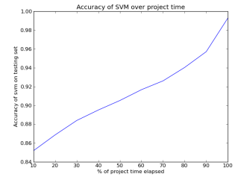

(Figure 22)

The machine learning algorithm used in the analysis was a support vector machine. The machine learning done was supervised using labelled data. Out of the 20,000 projects in the dataset, 1000 projects were used for testing of the supervised learning done and the rest was for training. [26]

Python was the programming language used in the analysis of the dataset. The machine learning library used was scikit, scikit - features classification, regression and clustering algorithms including support vector machines to be used in a Python project. Out of the test projects that were predicted correctly, the features were determined to be used in the prediction. [26]

Once the model was trained, the python code could be used in applications to predict any Kickstarter project with all the given information provided by the project compared with the dataset used in the analysis.(Figure 23) [26]

## 

(Figure 23)

By checking Kickstarter’s projects probability of success using the prediction model, people could make better decisions whether or not to pledge money to certain projects, it will save people money if a project was predicted to fail. If a project is new and not a lot of money has yet been pledged, it will be more of a risk as the model has not yet improved its accuracy of prediction and thus the estimated success would be misleading to pledgers. [26]

The analysis done on the projects were ethical and considerate to the project owners as the project owners had to sign a waiver to the terms and condition. The predicted success of projects can be showcased on the project pages, but only by authorisation by the project owners. [26]

The assumption could be made that the dataset was underfitted due to the low accuracy of initial training but the fact is that the features were not high enough of contribution to determine the success of a project but in fact by increasing training time by measuring Pledge over time for projects, then accurate predictions can be made. [26]

## Outcome

From this analysis done and prediction model created, Kickstarter’s projects can accurately be predicted for success or failure. [26]

## From the predictions made, people can make better decisions of which projects they should be backing by pledging money to those projects. Out of the predictions made, Kickstarter will increase the number of successful projects coming out of using Kickstarter’s services and decrease the amount of failed projects in the future. The reputation of Kickstarter is improved as projects have a better success rate and more reputable organisations are coming out of Kickstarter. A project’s goal for funding may be small where the funding required will be met very quickly or big enough where a project may only become successful in a year or two, the predictions made may be useful in some cases and some not but it’s a useful tool to get more insight on a projects progress and success rate. [26] [33]

## Why data analytic’s approaches/methods were used

The predictive analysis methods/approaches used in the case study were used to predict the likelihood of future outcomes based on the data. By analysing whether a Kickstarter project would be successful or not, we can pinpoint the key factors that contributes to a project’s success. The factors include: looking at the historical data of a project, the project's funding goal, the length of the funding period, the type of rewards offered, and the marketing strategy used. By looking at all the factors, potential backers of a project can make more informed decisions about whether to support a project.

The predictive models that we train on the data, we can identify the patterns and trends that will suggest future outcomes. In answering one of the questions “What will the future sales look like for the product”, the predictive model would be able to forecast the future sales. By observing the analysis done, we can take actions in order to achieve or desired outcomes.

# Bibliography

Predictive analysis:

[24] MOUILLÉ, M., 2018. Kickstarter Projects. *Kickstarter Projects*, [Online]. 1, 1. Available at: <https://www.kaggle.com/datasets/kemical/kickstarter-projects?datasetId=4104&sortBy=voteCount> [Accessed 23 March 2023].

[25] BANSAL, S., 2019. An Insightful Story of Crowdfunding Projects!. *Kickstarter Projects*, [Online]. 9, 1. Available at: <https://www.kaggle.com/code/shivamb/an-insightful-story-of-crowdfunding-projects> [Accessed 23 March 2023].

[26] Chen, K., Jones, B., Kim, I. and Schlamp, B., 2023. KickPredict: Predicting Kickstarter Success. *caltech.edu KickPredict: Predicting Kickstarter Success*, [Online]. 1, 6. Available at: <http://courses.cms.caltech.edu/cs145/2013/blue.pdf> [Accessed 12 April 2023].

[27] kickstarter. 2023. Our mission is to help bring creative projects to life.. [ONLINE] Available at: <https://www.kickstarter.com/about?ref=global-footer>. [Accessed 12 April 2023].

[28] medium. 2018. Kickstarter Is a PBC. Here’s What That Means and Why It Matters.. [ONLINE] Available at: <https://medium.com/kickstarter/kickstarter-is-a-pbc-heres-what-that-means-and-why-it-matters-d90b2389ea6c>. [Accessed 12 April 2023].

[29] kickstarter. 2023. Our story, as told by founder Perry Chen. [ONLINE] Available at: <https://www.kickstarter.com/about?ref=global-footer#the-full-story>. [Accessed 12 April 2023].

[30] kickstarter. 2023. Our Rules. [ONLINE] Available at: <https://www.kickstarter.com/rules>. [Accessed 12 April 2023].

[31] investopedia. 2023. What Is Predictive Analytics Good for?. [ONLINE] Available at: <https://www.investopedia.com/terms/p/predictive-analytics.asp#:~:text=Predictive%20analytics%20is%20good%20for,and%20increase%20efficiency%20and%20profitability.>. [Accessed 12 April 2023].

[32] online. 2023. WHAT IS PREDICTIVE ANALYTICS? 5 EXAMPLES. [ONLINE] Available at: <https://online.hbs.edu/blog/post/predictive-analytics>. [Accessed 12 April 2023].

[33] kickstarter. 2023. The Kickstarter Fulfillment Report. [ONLINE] Available at: <https://www.kickstarter.com/fulfillment>. [Accessed 12 April 2023].

[34] wikipedia. 2023. scikit-learn. [ONLINE] Available at: <https://en.wikipedia.org/wiki/Scikit-learn>. [Accessed 12 April 2023].

# ANALYSIS OF MENTAL HEALTH ISSUES AND ITS IMPLICATIONS ON CABINCREW AT EMIRATES AIRLINES – case study on Emirates airlines

## Background



Emirates is an airline company based in Garhoud, Dubai. The airline is one of many subsidiaries of the Emirates group, owned by the government of Dubai’s investment corporation. The organization was founded in 1985 and is known today as the fourth-largest airline company by passenger-kilometers flown. The airline operates with a fleet size of 262, of that 119 aircraft are Airbus A380 and the rest are Boeing 777. From the start of the airline company, the business has always been headed by the current chairman Ahmed bin Saeed Al Maktoum. [36] [37] [39] [40]

Emirates provides a host of options for classes: economy class, business class and first class. What your getting from Emirates airlines as a passenger is - a safe relaxing journey from one location to another location. Emirates had always turned over yearly profits until the travel restrictions in 2021 due to the global pandemic caused a loss of revenue by 66%. Emirates has had a competitive edge over its competitors as Emirates airways has a higher cost base and allows its airlines to bypass traditional airline hubs by repositioning itself as a global carrier. [36] [37] [39] [40]

As of 31 March 2020, the organization has 59,519 staff which: 21,789 are cabin crew and 4,313 are flight deck crew. Emirates provides benefits to its employees such as: health plans, profit sharing, merit pay, paid maternity and sick leave. [36] [37] [39] [40]

The problem that Emirates has been facing in the recent years, is the mistreatment of staff, and the mental health issues that cabin crew has been faced with working under Emirates airways. The case study this report is writing on, will investigate further into the findings of the analysis done and discover the comprehensive plan to overcome the challenges and problems faced. [36] [37] [39] [40]

## Introduction

Mental health is an issue that has been plaguing the aviation industry for the longest of times due to high stress. Jobs in the aviation industry are mentally and physically taxing. The case study will focus on cabin crew in particular, as they are often overlooked in other studies. [35]

The goal of the analysis was to gather insights on the levels of stress faced by Emirates airlines cabin crew and to then formulate a plan going forward from the insights on the actions that should be taken and the strategies that should be enforced on. [35]

Descriptive analysis, Diagnostic analysis and Prescriptive analysis was done on the case study, but the report will investigate further into Prescriptive analysis. [5]

Why use prescriptive analysis? You use data analysis to clean, change and process raw data/information to extract relevant information that can be taken action on, this process helps businesses make more informed business decisions. Prescriptive analysis involves using algorithms, machine learning, statistical methods and computational modeling. The patterns and pathways analyzed from the data drives the conditions and decisions. [5]

There are four types of Data analysis: Diagnostic analysis that focuses on why an occurrence happened by looking at patterns in the data from the future and the present, Predictive analysis that focuses on what is likely to happen in the future by looking at patterns in the data to predict future events, Prescriptive analysis you look at what needs to be done for a certain problem using the insights you have gathered, and lastly Descriptive analysis you focus on what happened at a certain occurrence in time. [5]

## Prescriptive analysis

Prescriptive analysis – the process of using data to determine recommended courses of actions and strategies to be taken. [41] [42] [43]

Machine-learning algorithms are used in Prescriptive analytics to sift through Big data. The machine learning algorithms and statistical models find patterns in big data so that possibilities can be determined, and actions can be recommended. [41] [42] [43]

The recommendations formulated must not be taken at face value as humans must make the final decisions on the recommendations. You base your analysis on the questions you want to answer and then recommendations are made to facilitate answering those questions. Analysis can be done manually; algorithms can be developed, or third-party analytics tools can be used that already have built in algorithms. Depending on the Prescriptive analytics system you are using, the algorithms make assumptions about the data, the algorithm checks for structure and completeness of the data. Prescriptive analysis is not perfect thus maintenance and monitoring needs to be done on the data and the predictions made. If there is problems with the quality of the data then false predictions can be made, overfitting of the data can make predictions inflexible and therefore cannot handle change in the data over time. [41] [42] [43]

By using Prescriptive analytics, a roadmap to reaching revenue goals to make forecasts come true. Across the divisions in a business, the analysis work done is helping to optimize performance and the profits made.

For customer retention – examples of prescriptive analytics in business are when the best actions are taken to the benefit of the customer/client and when the next best offers are offered.

## Organizational Problem

The cabin crew of Emirates airlines are required to:

* Be 21 years and older.
* Have an arm reach of 212 cm while standing on tiptoes.
* Minimum height of 5’2” (160 cm).
* Have a matric certificate.
* Be fluent in English.
* Have no visible tattoos while wearing uniform.
* Be medically and physically fit according to the role requirements.
* Have a positive attitude for providing customer service.

Emirates airways started off small being funded by the Dubai royal family and Pakistan International Airways. With a startup capital of $10 million dollars from Dubai’s royal family and planes being provided by Pakistan International Airways, Emirates airways was able to repay Dubai’s royal family back the money and the business was now on a journey to becoming one of the best airlines in the world. [45]

Maurice Flanagan brought up the airline at the very beginning. Tim Clark is the airlines president till this day. Sheikh Ahmed bin Saeed Al Maktoum is the current chairman and CEO of the airline. Emirates airline’s vision for the business is that:

* There is excellence in everything they do.
* They are agile – impacting thousands as they do everything as one.
* They are innovative – they strive to do better than other airlines.
* They strive for strong leadership – setting good examples.
* They strive to be reliable.

A cabin crew member’s requirements of employment state that you have to be physically and medically strong for the job. What about a cabin crew member’s mental state? From surveys and interviews conducted with cabin crew staff, there are a number of problems with the job that need to solved. [46]

Although aircrafts cover thousands of miles and fly all around the world is difficult for the human brain to comprehend what theses aircrafts are capable of, it is crucial to understand the mental health implications regarding the job of a cabin crew member. [46]

From customer reviews on TripAdvisor, Emirates cabin crew service received 4.5-star reviews on average, majority of the customers being pleased. [48]

The competitive advantage that Emirates airlines seeks to achieve through this analysis is that Emirates airlines is the company that listens to its staff members, they are the airline company that takes actions to improve the working conditions of their staff members.

As of today there are no trade unions established in the UAE, there are no trade unions within Emirates airlines. Looking to the future, how cabin crew members could get more involved in tackling issues related to their jobs, they could form a trade union or have a representative so that the employees get their words across to management. [49]

# Data analytics approaches/methods

## Data collection

Survey data was collected through SurveyMonkey.com website, the surveys used were a primary source of data collection as data could be collected directly from the cabin crew members of Emirates airlines. A total number of 45 questions were asked in the survey, choices ranging from 1-5 to how stressful their psychological or physiological states were. Interviews were also conducted with Emirates cabin crew members face-to-face, this is a primary source of data collection. No personal information was disclosed in either the survey or the interview. [35]

A sample size of around about 300 people was taken, the participants were approached through word of mouth and through social media. In total 378 participants took the online survey, 240 completed the survey.Quantitative data was obtained from the survey as numerical values were given to answer in the questions, these values could then be used to analyse the statistics of the data. Qualitative data was obtained from the interviews conducted, the interviews helped to discover the underlying problems and figure out solutions. [35]

Mental health by itself is difficult to understand and difficult to solve fully therefor it was important that enough data was collected with enough viewpoints from participants so that the predictions made in the analysis was accurate enough. [35]

## Data cleaning

There were multiple problems with the data that had to be delt with before the analysis could take place – not every participant completed their surveys so their answers had to be removed from the data, also in the survey some questions had to be answered with a yes that was indicated as a 1 in the data and a no indicated as a 0 in the data but there where questions where a no was a 1 and yes was a 0 so it is important that the information is not represented incorrectly. [35]

The questionnaire was originally generic in the sense that stress levels tested were for the ordinary person but was then changed to be more aviation related, the questions where changed to target cabin crew members in particular. [35]

## Data analysis

The scoring scheme for the surveys – responses for ‘yes’ were given a 1 and responses for ‘no’ received no points, for 5 points or less: individuals are less likely to suffer from stress on the job, for 6 to 17 points received: individuals are more likely to experience stress on the job, for 18 points or more: individuals are most likely to experience stress on the job. [35]

Questions we wanted answering from the analysis done included:

* What should be done by Emirates Airlines to provide an appropriate measure to help relieve stress?
* What Emirate Airline’s policies needs to be changed so that you do not experience time pressure?
* What should be done to relieve peer pressures from work colleagues?
* What can be done to make the job less stressful compared to your previous work done?
* What can be done so that the chief flight attendant can alleviate stress for you?
* What changes in the workload, workplace or personal lifestyle can help to reduce stress?

The qualitative data collected from the interviews helped to observe the patterns of stress amongst all the cabin crew members, body language was also taken into account when the participants were answering certain questions. [35]

From the data collected on why cabin crew wanted to take the job helped to formulate solutions to the problems causing stress on the job. (Figure 24)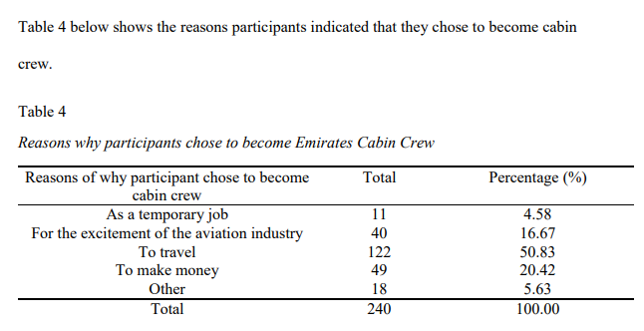(Figure 24)

Multiple stress factors have to be improved on, as seen by this figure below on the amount of participants experience these stressors. (Figure 25)

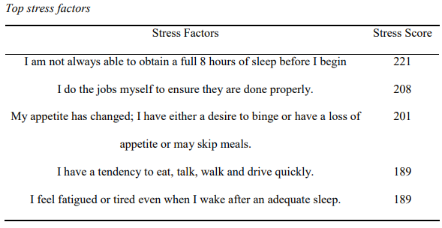(Figure 25)

Answers received from the Interview questions were good contributors to coming up with solutions for the questions in the analysis, these included:

* Benefits that cabin crew receive help to reduce stress: accommodation, travel benefits and discounts.
* Days off help to reduce stress but there are not enough days off.
* Events, seminars and socials hosted by the company contributes to a better lifestyle.
* Rostering policies need to be changed and improved on as this schedule clashes with cabin crews own lives.
* Policy of on stand-by work needs to change as this adds to the stress. Although rest periods are provided and enforced on, this rule is often broken, the rule has to be stricter so that crew members get the required rest.
* Security checks done on cabin crew have to be more thoroughly done.
* Policies checking beauty and weight needs to be more respectfully done and be more understanding (more inclusive).
* Seniority peer pressure in the workplace adds to the pressure to perform, peer pressure needs to be made aware of through a campaign in the workplace.
* Cabin crew members wear many hats on the job not in the literal sense, the job is a lot more demanding than other jobs, roles need to be assigned or work reduced to alleviate this stressor.
* The chief flight attendant role needs to be revised as it adds stress to the job of cabin crew members rather than relieving stress.
* Physical activity separate from the job needs to be allowed and encouraged on as it helps to further reduce stress.
* Cabin crew members receiving rosters a week in advance would help to alleviate stress as crew members can plan their lives around the roster.
* Meditation needs to be encouraged as it helps to reduce stress.
* The communication gap between cabin crew and the upper management needs to be closed on, so that cabin crew gets their concerns across and so then action can be taken.
* Rostering system has to change so that it is more civilized and appreciative, this could be done by hiring more staff.

## Outcome

The purpose of the report was to develop solutions to patterns identified in the data analysis done in the case study, the patterns that needed solving was that of stress levels and mental health issues faced with doing a cabin crew job in Emirates airway’s company. [35]

The Prescriptive analysis results found are as follows:

* It is recommended that Emirates Airlines should raise awareness for mental health issues and peer pressure in the workplace.
* It is recommended that rostering procedures need to be adjusted.
* It is recommended that Emirates’ cabin crew members get enough rest before commencing work.
* It is recommended that the amount of exercise and sleep needs to be focused more on so that the cabin crew members live a healthier lifestyle.
* Emirates airlines needs to hire more staff.
* It is recommended that cabin crews’ behaviour needs to be monitored.
* When inspections take place, there needs to be more of a focus on health rather than appearance.
* The mental health of crew members needs to be more routinely checked.

## Why data analytic’s approaches/methods were used

The Prescriptive analysis methods/approaches we used for the case study helped us in identifying the best course of action to achieve a desired outcome. The analysis makes recommendations and provides solutions to the problems at hand. The purpose of the analysis is to help the decision-makers optimize the decision-making process for the project. The analysis can help us in solving multiple questions and problems such as “How can we improve the mental state of cabin crew members?”. The analysis can also help in addressing needed changes in Emirates Airlines policies and practices, to reduce time pressure and make the job less stressful.

Prescriptive analysis is useful in addressing the complex problems that Emirates Airlines is facing, by analysing the data. The analysis done will help the organization to make better decisions and achieve their desired outcomes.

# Bibliography

Prescriptive analysis.

[35] Mumtaz, S., 2017. ANALYSIS OF MENTAL HEALTH ISSUES AND ITS IMPLICATIONS ON CABIN CREW AT EMIRATES AIRLINES. *Thesis Submitted in Partial Fulfillment of the Requirements for the Degree of Master of Science in Aviation Administration*, [Online]. 1, 85. Available at: <https://jewlscholar.mtsu.edu/server/api/core/bitstreams/b3490744-40f1-4c8e-a4b2-17cd4d34c84b/content> [Accessed 12 April 2023].

[36] wikipedia. 2023. Emirates (airline). [ONLINE] Available at: <https://en.wikipedia.org/wiki/Emirates_(airline)>. [Accessed 12 April 2023].

[37] emirates. 2023. About us. [ONLINE] Available at: <https://www.emirates.com/za/english/about-us/>. [Accessed 12 April 2023].

[38] emiratesgroupcareers. 2023. Discover a world of opportunities. [ONLINE] Available at: <https://www.emiratesgroupcareers.com/>. [Accessed 12 April 2023].

[39] emirates. 2023. Our people. [ONLINE] Available at: <https://www.emirates.com/za/english/about-us/our-people/>. [Accessed 12 April 2023].

[40] emirates. 2023. Our communities. [ONLINE] Available at: <https://www.emirates.com/za/english/about-us/our-communities/>. [Accessed 12 April 2023].

[41] stitchdata. 2023. Prescriptive Analytics Guide: Use Cases & Examples. [ONLINE] Available at: <https://www.stitchdata.com/resources/prescriptive-analytics/#:~:text=Predictive%20analytics%20uses%20data%20to,that%20human%20analysts%20may%20miss.>. [Accessed 12 April 2023].

[42] strategiccfo360. 2023. How Prescriptive Analytics Helps Maximize Revenue For Your Company. [ONLINE] Available at: <https://strategiccfo360.com/whats-next-in-analytics-using-prescriptions-to-deliver-revenue/#:~:text=By%20leveraging%20prescriptive%20analytics%2C%20CFOs,costs%20and%20likely%20revenue%20delivered.>. [Accessed 12 April 2023].

[43] tbmcg. 2023. Use Prescriptive Analytics to Make Decisions that Will Help Your Company Make More Money. [ONLINE] Available at: <https://www.tbmcg.com/resources/blog/use-prescriptive-analytics-to-make-more-money/>. [Accessed 12 April 2023].

[44] getthematic. 2023. Customer retention analytics: 5 strategies to reduce churn. [ONLINE] Available at: <https://getthematic.com/insights/5-ways-data-and-text-analytics-improve-customer-retention/#:~:text=For%20customer%20retention%2C%20examples%20of,and%20next%20best%20offer%20analysis.&text=This%20is%20the%20most%20commonly,in%20a%20future%2C%20specific%20situation.>. [Accessed 12 April 2023].

[45] cabincrewwings. 2023. Emirates Cabin Crew Requirements. [ONLINE] Available at: <https://www.cabincrewwings.com/blog/airlines/emirates-cabin-crew-requirements/>. [Accessed 12 April 2023].

[46] simpleflying. 2023. The Rise Of Emirates: A PIA Investment To Global Mega Airline. [ONLINE] Available at: <https://simpleflying.com/rise-of-emirates/?newsletter_popup=1>. [Accessed 12 April 2023].

|  |
| --- |
|  |
| [47] emiratesgroupsecurity. 2023. Vision, Mission & Values. [ONLINE] Available at: <https://www.emiratesgroupsecurity.com/about-us/vision-and-mission#:~:text=Excellence%20%E2%80%93%20in%20everything%20we%20do,on%20us%20to%20get%20results.>. [Accessed 12 April 2023].  [48] emirates. 2023. Emirates Reviews. [ONLINE] Available at: <https://www.emirates.com/za/english/experience/review/>. [Accessed 12 April 2023]. |
| [49] ilo. 2023. United Arab Emirates. [ONLINE] Available at: <https://www.ilo.org/beirut/countries/united-arab-emirates/WCMS_533531/lang--en/index.htm#:~:text=There%20are%20still%20no%20independent,for%20redress%2C%20and%20file%20grievances.>. [Accessed 12 April 2023]. |